02. Optimization

- Stochastic Gradient Descent

In Stochastic Gradient Descent, you use only one training example before updating the gradients. When the training set is large, SGD can be faster, but the parameters will oscillate toward the minimum rather than converge smoothly.
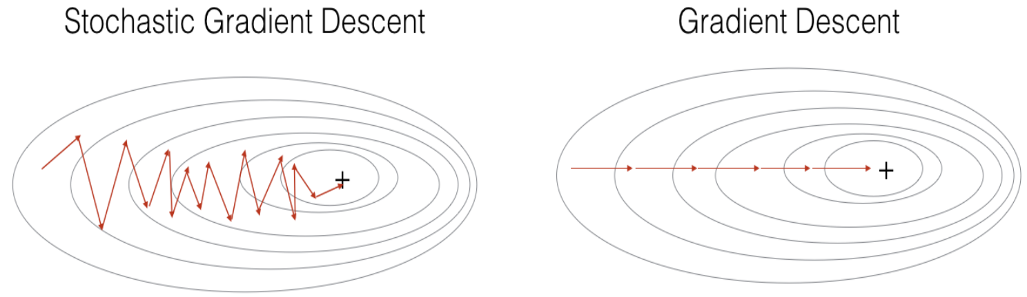

The following shows the Batch Gradient Descent algorithm.
- Initialize $W^{[l]}$ and $b^{[l]}$ for $l=1, 2, …, L$
- For $k=1 to iterations$ (large iteration, such as 1000)
Compute $Z^{[l]}$ and $A^{[l]}$ for $l=1, 2, …, L$ using forward propagation - the whole set $X$
Compute cost using $A^{[L]}$ and $Y$
Compute ${dZ}^{[l]}$, $dW^{[l]}$, and ${db}^{[l]}$ for $l=L-1, …, 2$ using backpropagation
Update parameters $W$ and $b$

The following shows the Stochastic Gradient Descent algorithm.
- Initialize $W^{[l]}$ and $b^{[l]}$ for $l=1, 2, …, L$
- For $k=1 to iterations$ (small iteration, such as 10)
For $i=1 to m$
Compute $Z^{[l]}$ and $A^{[l]}$ for $l=1, 2, …, L$ using forward propagation. – only $X^{(i)}$
Compute cost using $A^{[L]}$ and $Y^{(i)}$
Compute ${dZ}^{[l]}$, $dW^{[l]}$, and ${db}^{[l]}$ for $l=L-1, …, 2$ using backpropagation
Update parameters $W$ and $b$

- Mini-Batch Gradient Descent

In Mini-Batch Gradient Descent, you loop over the mini-batches instead of looping over the whole training examples.
- Initialize $W^{[l]}$ and $b^{[l]}$ for $l=1, 2, …, L$
- For $k=1 to iterations$
For each batch:
Compute $Z^{[l]}$ and $A^{[l]}$ for $l=1, 2, …, L$ using forward propagation. – using $X_{batch}$
Compute cost using $A^{[L]}$ and $Y_{batch}$ - $m=batch size$
Compute ${dZ}^{[l]}$, $dW^{[l]}$, and ${db}^{[l]}$ for $l=L-1, …, 2$ using backpropagation
Update parameters $W$ and $b$

In Mini-Batch Gradient Descent, the parameters oscillate toward the minimum, but convergence is faster than Stochastic Gradient Descent because it can use vectorization. The batch size usually should be a power of 2, such as 64, 128.

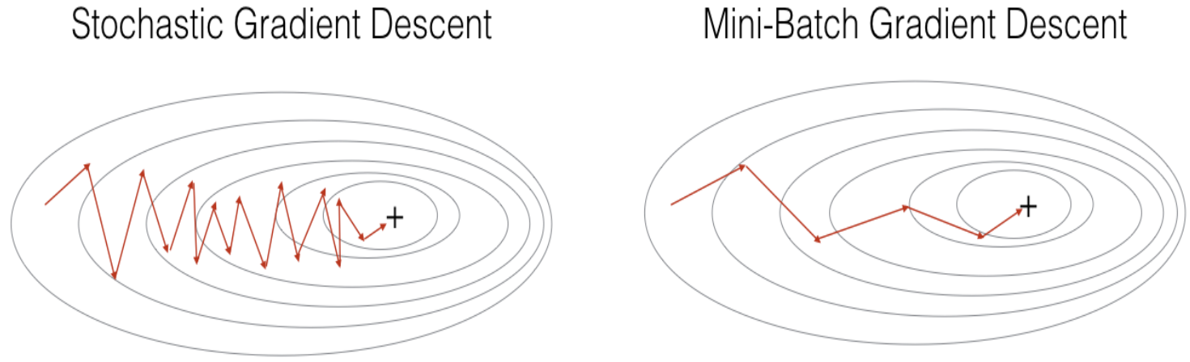

Before running Mini-Batch Gradient Descent algorithm, we need to shuffle the training set, to ensure that the training examples will be split randomly into different mini-batches.

permutation = list(np.random.permutation(m))

shuffled_X = X[:, permutation]
shuffled_Y = Y[:, permutation].reshape((1,m))

- Momentum

Momentum takes past gradients into account to smooth out the steps of gradient descent. It can be applied with Batch Gradient Descent, Mini-Batch Gradient Descent, or Stochastic Gradient Descent. We store the direction of the previous gradients in velocity variables $v_{{dW}^{[l]}}$ and $v_{{db}^{[l]}}$, which are initialized with 0's. The algorithm will take a few iterations to build up velocity and start to take bigger steps.
$$v_{{dW}^{[l]}}=0 (for l=1, 2, …, L)$$
$$v_{{db}^{[l]}}=0 (for l=1, 2, …, L)$$

The velocity variables $v_{{dW}^{[l]}}$ and $v_{{db}^{[l]}}$ have the same shapes as $W^{[l]}$ and $b^{[l]}$, respectively.

for l in range(L):
vdW[l+1] = np.zeros((W[l+1].shape[0], W[l+1].shape[1]))
vdb[l+1] = np.zeros((b[l+1].shape[0], 1))

The parameter $β$ is called momentum. The larger $β$ is, the smoother the update because the more we take the past gradients into account. But if $β$ is too big, it could also smooth out the updates too much. Normally, you can set $β=0.9$. The follow shows how to update gradients.
$$v_{{dW}^{[l]}}=β∙v_{{dW}^{\left[l\right]}}+(1-β)∙{dW}^{[l]}$$
$$v_{{db}^{[l]}}=β∙v_{{db}^{\left[l\right]}}+(1-β)∙{db}^{[l]}$$
$$W^{[l]}=W^{[l]}-α∙v_{{dW}^{[l]}}$$
$$b^{[l]}=b^{[l]}-α∙v_{{db}^{[l]}}$$

- RMSprop

RMSprop is similar to momentum. On each layer, it computes $W^{[l]}$ and $b^{[l]}$ as below.
$$s_{dW}=β∙s_{dW}+(1-β)∙{dW}^{2}$$
$$s_{db}=β∙s_{db}+(1-β)∙{db}^{2}$$
$$W=W-α∙\frac{dW}{\sqrt{s_{dW}+ε}}$$
$$b=b-α∙\frac{db}{\sqrt{s_{db}+ε}}$$

- Adam

Adam is one of the most effective optimization algorithms for training neural networks. It combines ideas from RMSProp and Momentum. The parameter $t$ counts the number of steps taken of Adam (the number of epochs). The parameter $ε$ is a very small number to avoid dividing by zero.
$$v_{dW}=β_{1}∙v_{dW}+\left(1-β_{1}\right)∙dW$$
$$v_{db}=β_{1}∙v_{db}+\left(1-β_{1}\right)∙db (usually β_{1}=0.9)$$
$$s_{dW}=β_{2}∙s_{dW}+\left(1-β_{2}\right)∙{dW}^{2}$$
$$s_{db}=β_{2}∙s_{db}+(1-β_{2})∙{db}^{2} (usually β_{2}=0.999)$$
$$v_{dW}^{corrected}=\frac{v_{dW}}{1-{β_{1}}^{t}}, v_{db}^{corrected}=\frac{v_{db}}{1-{β_{1}}^{t}}$$
$$s_{dW}^{corrected}=\frac{s_{dW}}{1-{β_{2}}^{t}}, s_{db}^{corrected}=\frac{s_{db}}{1-{β_{2}}^{t}}$$
$$W=W-α∙\frac{v_{dW}^{corrected}}{\sqrt{s_{dW}^{corrected}+ε}}, b=b-α∙\frac{v_{db}^{corrected}}{\sqrt{s_{db}^{corrected}+ε}} (usually ε=1e-8)$$

- Learning Rate Decay

As learning approaches convergence, having a slower learning rate allows you to take smaller steps. One epoch is one pass of the data set, i.e. one iteration. (same as t in Adam)
$$α=α∙\frac{1}{1+decay_rate* epochs}$$

When choosing hyperparameters:
- Don't use a grid; instead, try random values.
- Use coarse to find sampling schema.
- Use appropriate scale for hyperparameters. For example, randomly choose the values between 0.0001 – 0.001 – 0.01 – 0.1 – 1, instead of randomly choose between 0.0001 – 1.
- The hyperparameters can be stale. You need to retest hyperparameters occasionally.
- Babysitting one model if you have a large dataset and limited computation resources. Training many models in parallel if you have enough computation resources.

- Batch Normalization

Besides normalizing the input $x$, you can also normalize $z's$ on every layer. Adding learning parameters $γ$ and $β$ in order not to make the hidden units to always have mean 0 and variance 1.
$$μ=\frac{1}{m}∙\sum_{i=1}^{m}{z^{\left(i\right)}}, σ^{2}=\frac{1}{m}∙\sum_{i=1}^{m}{{\left(z^{\left(i\right)}-μ\right)}^{2}}$$
$$z_{norm}^{ \left(i\right)}=\frac{z^{\left(i\right)}-μ}{\sqrt{σ^{2}+ε}} (ε is a small number in case that σ^{2}=0)$$
${\hat{z}}^{\left(i\right)}=γ∙z_{norm}^{ \left(i\right)}+β$ ($γ and β are learning parameters$)

The following shows how to use batch normalization in Mini-Batch Gradient Descent.
- For $t=1 to (number of batches)$
Compute forward propagation on current batch
In each hidden layer, use ${\hat{z}}^{[l]}$ instead of $z^{[l]}$.
Use backpropagation to compute $dW, dβ, dγ$.
We don't need $db$ because it will be wiped out when computing the mean, so just set $b$ to 0's or ignore it.
Update parameters
$$W=W-α∙dW$$
$$β=β-α∙dβ$$
$$γ=γ-α∙γ$$

During training time, $μ$ and $σ^{2}$ are computed on the entire min-batch. During test time, a single example is processed at a time, so you use the $μ$ and $σ^{2}$ values computed at training time to compute $\hat{Z}$. In practice, people usually implement exponentially weighted average (such as Adam) to keep track of the $μ$ and $σ^{2}$ values.

- Softmax Regression

In a multiclass classification, the last layer is called a Softmax layer.
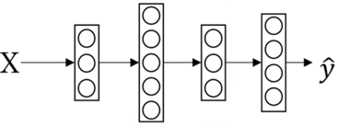

The following shows the Softmax activation function.
$$z^{\left[L\right]}=W^{\left[L\right]}∙a^{\left[L-1\right]}+b^{\left[L\right]}$$
$$a_{i}^{[L]}=\frac{t_{i}}{\sum_{j=1}^{C}{t_{j}}}, where t_{i}=e^{z_{i}^{[L]}} and C is the number of classes$$

The following shows an example.
$$z=\left[ \begin{aligned}5 \\ 2 \\ -1 \\ 3\end{aligned} \right] → t=\left[ \begin{aligned}148.4 \\ 7.4 \\ 0.4 \\ 20.1\end{aligned} \right] → a=\left[ \begin{aligned}0.842 \\ 0.042 \\ 0.002 \\ 0.114\end{aligned} \right] Note:g(z)=\left[ \begin{aligned}0.993 \\ 0.881 \\ 0.269 \\ 0.923\end{aligned} \right]$$

Comparably, the Hard-Max Function maps the maximum element to 1, and other elements to 0.
$$\left[ \begin{aligned}0.842 \\ 0.042 \\ 0.002 \\ 0.114\end{aligned} \right] → \left[ \begin{aligned}1 \\ 0 \\ 0 \\ 0\end{aligned} \right]$$

- Project Analysis

There are some rules in building a machine learning algorithm.
- Use a single real number evaluation metric will tell you which algorithm is the best one you can choose. For example, instead of using precision and recall, you can use F1 score to evaluate an algorithm.
- The dev set tells where to aim the target. Dev and test sets should come from the same distribution. The train set can be different, and this may cause a data mismatch error.
- A good algorithm may surpass human level performance, but never surpass the Bayes optimal error.
- Deep learning algorithms are quite robust to random errors in the training set. If some labels are wrong in the training set, you can leave them along and don't spend much time fixing them. If some labels are wrong in the dev or test set, you can fix them if it can improve the performance apparently.
- Build your first learning algorithm quickly and iterator.

- Transfer Learning

Transfer learning means that you transfer from one task you have learned to a different task. It can help the performance of your learning task significantly. You can transfer from task A to task B when:
- Task A and task B have the same input, such as image or audio.
- You have a lot more data for task A than task B.
- Low level features from A could be helpful for learning B.

To transfer learning from task A to B, you can remove the last layer and the weights form the neural network of task A, create a new set of randomly initialized weights just for the last layer, and output the new task B. Depending on how much data you have for task B, you can just retrain the new layers or even more layers of the neural network.

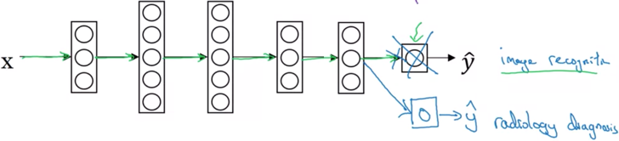
Sometimes you can also create several new layers to task B.

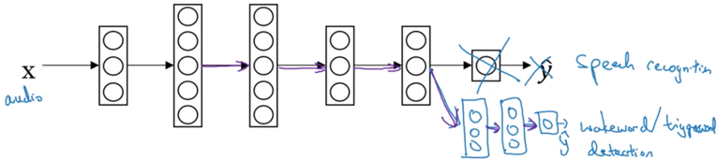

- Multi-Task Learning

A multi-task learning algorithm outputs multiple labels, for example, a self-driving learning algorithm can take an image as the input, and output four labels: pedestrian, car, stop sign, traffic light. Different from a softmax layer which outputs a hot vector, such as $\left\{0, 1, 0, 0\right\}$, a multi-task learning algorithm outputs a vector with any value, such as $\{1, 1, 0, 1\}$.

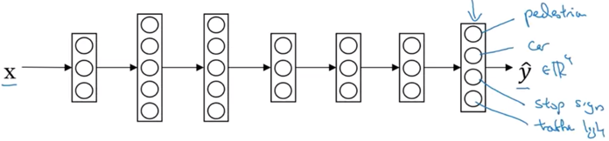

The following shows the loss function:
$${\hat{y}}^{(i)}=\frac{1}{m}\sum_{i=1}^{m}{\sum_{j=1}^{4}{L\left({\hat{y}}_{j}^{(i)}, y_{j}^{(i)}\right)}}=\frac{1}{m}\sum_{i=1}^{m}{\sum_{j=1}^{4}{\left[y_{j}^{(i)}∙\log{{\hat{y}}_{j}^{\left(i\right)}}+\left(1-y_{j}^{(i)}\right)∙\log\left(1-{\hat{y}}_{j}^{(i)}\right)\right]}}$$

You can also train four separate neural networks, each for a different output. If some of the earlier features in neural network can be shared between these different types of objects, using a multi-task learning neural network can have better performance if the neural network is big enough. In practice, transfer learning is used more often than multi-task learning. Multi-task learning is usually used in computer vision.

- End-to-End Deep Learning

The learning algorithms of some data processing systems require multiple stages of processing. An end-to-end deep learning replaces all these multiple stages with just a single neural network. If you have a smaller dataset, the traditional pipeline approach works better. If you have a large dataset, the end-to-end approach works better.

